The Money Market

Topic 5: Money demand

Difficulty Level 1
- The opportunity cost of holding money is
  - the nominal interest rate on less liquid assets
  - the federal funds rate
  - the discount rate
  - the mortgage rate
  - zero

Difficulty Level 2
- Why does the demand for money increase when national income increases?
  - The money supply increases
  - The budget deficit decreases
  - Interest rates increase
  - Spending on goods and services increases
  - Imports decrease
- How does an increase in price level affect the money market?
  - Money demand increases
  - Money demand decreases
  - Money demand does not change
  - Money supply decreases
  - Money supply increases
- An increase in the use of cell phones to provide electronic payment in stores will likely result in
  - an increase in money demand
  - a decrease in the money supply
  - an increase in nominal interest rates
  - a decrease in money demand
  - an increased opportunity cost for holding money
- Assume that there are no fees to access an ATM. If Congress then decides to impose a $5 tax on each ATM transaction, what will be the likely effect?
  - The use of ATMs will increase
  - Money demand will decrease
  - Sellers will only accept cash as payment
  - Price level will increase
  - Money demand will increase
- How will households and firms react to an increase in the nominal interest rate for interest-bearing bank accounts?
  - The quantity of money demanded will increase
  - The quantity of money demanded will remain constant
  - The quantity of money demanded will decrease
  - The amount of money used for transactions will increase
  - The opportunity cost of holding money will decrease

Topic 6: Money market and the equilibrium nominal interest rate

Difficulty Level 2
- If the public decides to increase its holdings of currency, which of the following is most likely to increase?
  - bank deposits
  - investment spending
  - price level
  - the interest rate
  - the unemployment rate
- Which of the following will most likely occur in an economy if the quantity of money demanded is greater than the quantity of money supplied?
  - The money demand curve will shift to the left
  - The money demand curve will shift to the right
  - Interest rates will increase
  - Interest rates will decrease
  - Excess reserves will decrease

Use the graph below to answer the following questions.
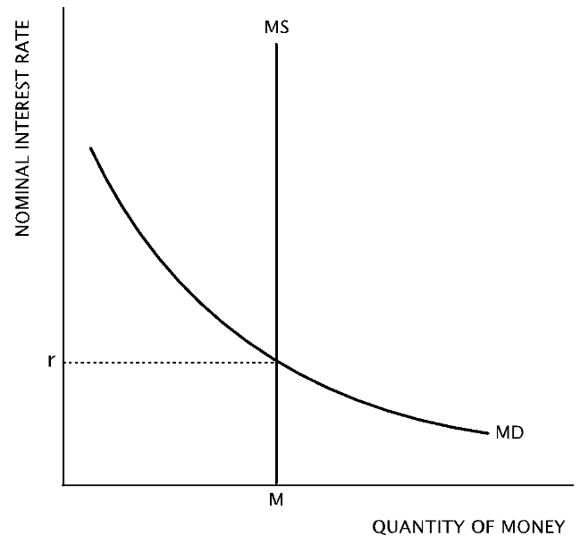
- According to graph above, what is the likely result if there is an increase in the money supply?
  - the nominal interest rate will decrease
  - the nominal interest rate will increase
  - money demand will increase
  - the quantity of money demanded will decrease
  - the equilibrium quantity of money will decrease
- According to the graph, which of the following changes will result in a decrease in the equilibrium nominal interest rate?
- An expansionary monetary policy
- An decrease in price level
- An increase in real gross domestic product
1 | A | 6 | C
2 | D | 7 | D
3 | A | 8 | C
4 | D | 9 | A
5 | E | 10 | D

  - I only
  - II only
  - III only
  - I and II only
  - II and III only

Answers

The Money Market

Topic 5: Money demand

Difficulty Level 1
- Correct answer: A
When money is held as a very liquid asset, such as cash or a checkable deposit, the opportunity cost is having the money deposited in an interest-bearing savings account, money market account, or invested in bonds.
Incorrect Answer
If one is not holding money as currency, where can the money be deposited? What is the advantage of keeping money on deposit at a bank?

Difficulty Level 2
- Correct answer: D
When national income increases, consumption spending increases and more money is demanded to make transactions.
Incorrect Answer
As incomes increase, people need more money for transactions.
- Correct answer: A
With a higher price level, the public must hold more money to pay for goods and services.
Incorrect Answer
Would you change the amount of cash you keep in your wallet if prices were higher?
- Correct answer: D
An increase in the use of technology that makes transactions more efficient reduces the demand for money. If people increasingly used phones to transfer money to sellers then more money could be left in interest-bearing accounts. Individuals would hold less cash.
Incorrect Answer
If you could pay for everything with your phone, would you carry as much cash?
- Correct answer: E
While the answer may seem counter-intuitive, money demand will increase as ATMs grow more expensive to use. If bank customers find it more expensive to withdraw money at ATMs, they must go to the bank to access their money. Since a trip to the bank is less convenient, customers will withdraw and hold more cash to reduce the necessary number of trips to the bank.
In general, the more access people have to banking and payment technology, the lower their money demand.
Incorrect Answer
If you stopped using ATMs, how much cash would you keep in your wallet?
- Correct answer: C
As the nominal interest rate increases, the opportunity cost of holding money increases. Households and firms will increase the quantity of money deposited in interest-bearing accounts at as interest rates increase.
Incorrect Answer
If you could earn more interest by keeping money deposited in a bank, would you deposit more money or hold more money as cash in your wallet?

Topic 6: Money market and the equilibrium nominal interest rate

Difficulty Level 2
- Correct answer: D
According to the money market, as money demand increases (due to the public increasing its money holdings), the equilibrium interest rate rises.
Incorrect Answer
It may be helpful to draw the money market model and shift money demand to the right. What factor changes as a result?
- Correct answer: C
The quantity of money demanded exceeds the quantity of money supplied when the interest rate is below equilibrium. At this low interest rate, investors will want to withdraw money from interest-bearing assets and increase their money holdings, which will drive up interest rates.
Incorrect Answer
Try to think of money as a type of good. If there is a higher quantity demanded of a good than there is supplied, what changes?
- Correct answer: A
If there is an increase in the money supply, the line that represents it on the graph will shift to the right. Since money demand does not change, the new equilibrium nominal interest rate will decrease.
Incorrect Answer
Use the provided graph to help determine the answer. What is the result when the money supply curve shifts to the right?
- Correct answer: D
To cause a decrease in the money market, money demand must decrease and/or the money supply must increase. An expansionary monetary policy causes an increase in the money supply and a decrease in price level causes a decrease in money demand.
If there was an increase in real gross domestic product, then consumption would increase, causing money demand to increase, thus eliminating this change as a correct option.
Incorrect Answer
Test each of the three changes on the graph to see which would cause the nominal interest rate to decrease. This type of question often appears on the AP exam without the aid of a graph, so you may need to draw your own.

